**Lab Report**

**Lab – 02**

**Course No: 3110**

**Course Name: Sessional Based on 3109 (Microprocessors and Assembly Language)**

**Submitted To:**

**Sadia Zaman Mishu**

**Assistant Professor,**

**Department of CSE, RUET**

**Submitted By:**

**Anika Tabassum Era**

**Roll: 1703176**

**Section: C**

**Experiment No: 02**

**Experiment Name: Write an assembly language program to read one of the HEX digits (A-F) and display it on next line in decimal.**

**Code:**

**.MODEL SMALL**

**.STACK 100H**

**.DATA**

**MSG1 DB 0AH, 0DH, 'Enter a hex digit: $'**

**MSG2 DB 0AH, 0DH, 'In decimal it is: $'**

**.CODE**

**MAIN PROC**

**;INITIALIZING PROMPT USER**

**MOV AX, @DATA**

**MOV DS, AX**

**; FIRST PROMPT USER MSG**

**LEA DX, MSG1**

**MOV AH,9**

**INT 21H**

**;INPUT HEX DIGIT**

**MOV AH, 1**

**INT 21H**

**MOV BL,AL**

**SUB BL,17D ;CONVERTING THE HEX CHARACTER IN DECIMAL**

**;LINE FEED**

**MOV DL,0AH**

**MOV AH,2**

**INT 21H**

**;CARRIAGE RETURN**

**MOV DL,0DH**

**MOV AH,2**

**INT 21H**

**;SECOND PROMPT USER MSG**

**LEA DX, MSG2**

**MOV AH,9**

**INT 21H**

**MOV DL,49D ;PRINTING "1" BEFORE BL**

**MOV AH,2**

**INT 21H**

**; PRINT THE CONVERTED VALUE THAT IS STORED IN BL**

**MOV DL,BL**

**MOV AH,2**

**INT 21H**

**;DOS RETURN**

**MOV AH, 4CH**

**INT 21H**

**MAIN ENDP**

**END MAIN**

**Output:**

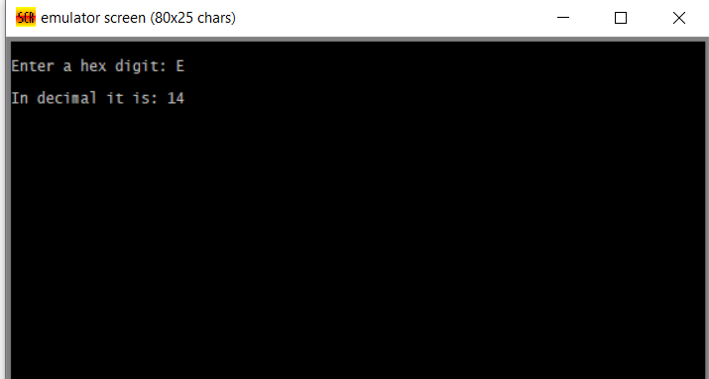

**Discussions:**

**In this specified problem the HEX digit was converted in the corresponding number according to the ASCI code interpretation. And the initial digit was set before displaying the corresponding converted HEX digit.**